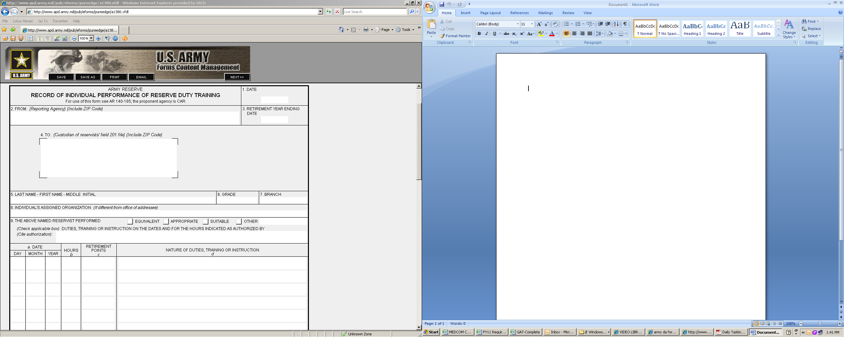

Your Info

20110127

20110127

Your Name

Your Unit

O3 Your Branch

Your Info

Write Here >>

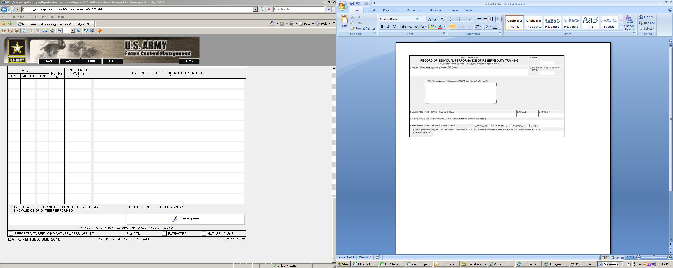

Name

???

???

11

11

1000

1000

2

2

2

2

2

1

1

1

1

1

Your Info

Info

Info