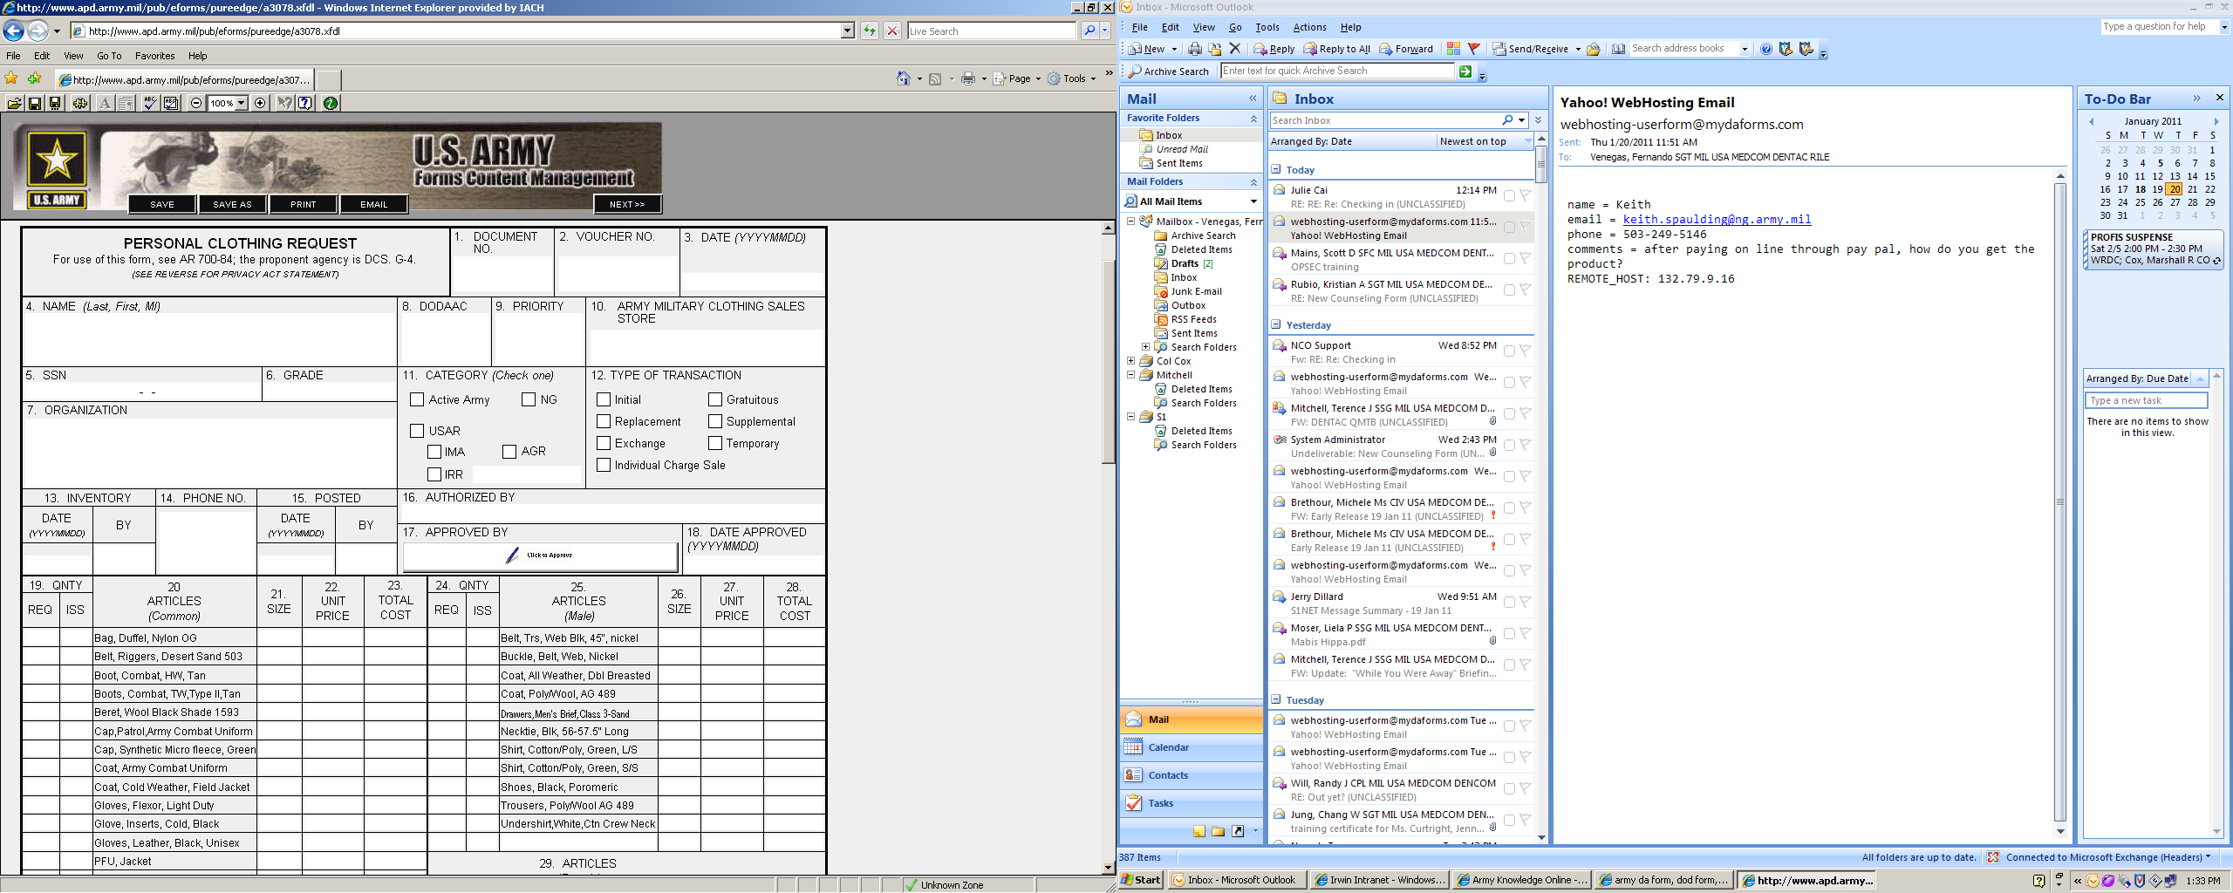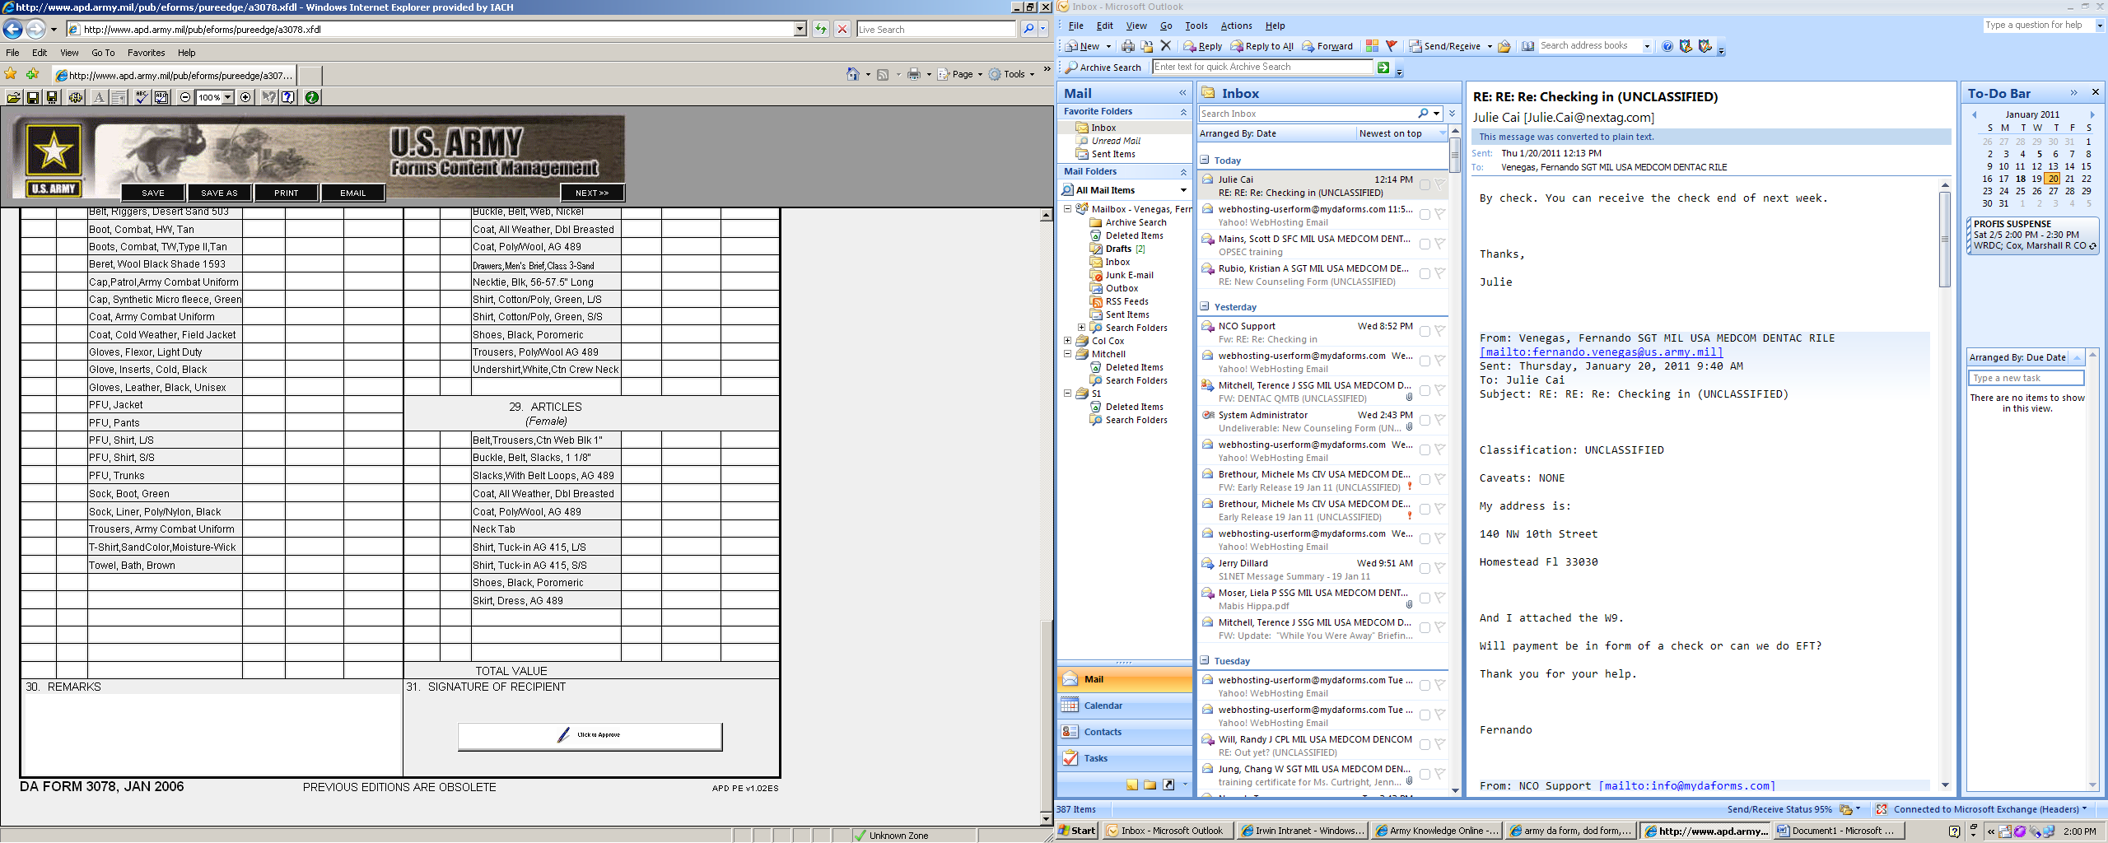

20110120

20110120

Write here >

Name

Name

Your Unit

555-55-55 E-4

Bush, George, W WZ1234 09 ?

001 002 20110120